**Murphey Middle School**

**Parental Involvement Policy and Plan for Shared Student Success**

**2024-2025**

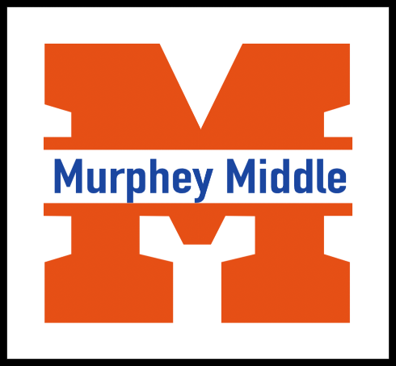

1921 Eagles Way, Augusta, GA 30904

706.737-7350

*Dr. Bettina Kyler*

*Principal*

**What is Title I?**

Murphey Middle is identified as a Title I school as part of the Elementary and Secondary Education Act of 1965 (ESEA). Title I is designed to support State and local school reform efforts tied to challenging state academic standards to reinforce and enhance efforts to improve teaching and learning for students. Title I programs must be based on effective means of improving student achievement and include strategies to support parental involvement. All Title I schools must jointly develop with parents a written parental involvement policy.

*Revised April 23, 2024*

**School Plan for Shared Student Achievement**

**What is it?**

This plan describes how Murphey Middle School will provide opportunities to improve parent engagement and support student learning. Murphey Middle believes that parent involvement means the participation of parents in regular two-way and meaningful communication about student academic learning and other school activities. We value the contributions and involvement of parents in establishing an equal partnership for the common goal of improving student achievement. This plan describes the different ways that Murphey Middle will support parent engagement and how parents can help plan and participate in activities and events to promote student learning at school and home.

**How it was created and how it is revised?**

EOY Title I meetings were held at all schools that would serve as the population for Murphey Middle School. Parents were invited to share their ideas and opinions in revising/creating a new school policy and compacts that would serve as the foundation for parental engagement at the newly established Murphey Middle School.

Revisions will occur throughout the year. Parents will be invited to the Annual BOY and EOY Title I meetings, as well as, Input/Revision meetings. Input/Feedback are welcomed anytime. Feedback/Comments sheets will be located in the Parent Resource Center located in the Media Center.

**Who is it for?**

All students participating in the Title I, Part A program, and their families, are encouraged and invited to fully participate in the opportunities described in this plan. Murphey Middle will provide full opportunity for the participation of parents with limited English, parents with disabilities and parents of migratory children.

**Where is it available?**

The plan is available on the school website and in the office. Parents can also obtain a copy from the Parent Resource Center located in the Media Center.

1



**2024-2025 District Goals**

Goal #1 During the 24-25 school year, we will increase student content mastery in tested subject areas on the Georgia Milestones by 5%

Goal #2 During the 24-25 school year, we will increase the number of highly effective

teachers and leaders retained in RCSS by 3%.

Goal #3 During the 24-25 school year, we will increase post-high school readiness by

increasing our graduation rate from 81% to 83%.

**2024-2025** ***Murphey School-wide***

***Improvement Goal***

Goal 1 During the 2024-2025 SY teachers will use specific instructional strategies during tier 1 instruction to move 35 percent of students into the next performance band as determined by GMAS.

Goal #2: During the 2024-2025 SY, teachers will implement a 45-minute structured intervention block to provide specific instructional strategies to decrease the percentage of students performing at the beginning level by 35 Percentage points as determined by GMAS.

Goal #3: By the end of the 2024-2025 SY, parent engagement and participation by establishing quarterly Student-led Conferences.

# **BUILDING CAPACITY FOR INVOLVEMENT**

Title I, Part A, Section 1116(e) of the Every Student Succeeds Act describes the six “shalls” stated in the law under Building Capacity for Involvement. The law provides eight additional “mays” (that are not required, but are allowable) to ensure meaningful capacity building of parents, family members, and school staff. To ensure effective involvement of parents and to support a partnership among the school involved, parents, and the community to improve student academic achievement, each school and local educational agency assisted under this part—

1. **SHALL provide assistance to** parents of children served by the school or local educational agency, as appropriate, in understanding such topics as the challenging State academic standards, state and local academic assessments, the requirements of this part, and how to monitor a child's progress and work with educators to improve the achievement of their children;
2. **SHALL provide materials and training to help parents** to **work with their children to improve their children's achievement**, such as literacy training and using technology (including education about the harms of copyright piracy), as appropriate, to foster parental involvement;
3. **SHALL educate teachers**, specialized instructional support personnel, principals, and other school leaders, and other staff, with the assistance of parents, in the value and utility of contributions of parents, and in how to reach out to, communicate with, and work with parents as equal partners, implement and coordinate parent programs, and build ties between parents and the school;
4. **SHALL, to the extent feasible and appropriate, coordinate and integrate parent involvement programs and activities** with other Federal, State, and local programs, including public preschool programs, and conduct other activities, such as parent resource centers, that encourage and support parents in more fully participating in the education of their children;
5. **SHALL ensure that information related to school and parent programs, meetings, and other activities is sent to the parents of participating children** in a format and, to the extent practicable, in a language the parents can understand;

(14) **SHALL provide such other reasonable support**  for parental involvement activities under this section as parents may request.

**Parent-School Compact,**

**Parent Survey and Parental Involvement Budget**

The school/parent compact, parental survey, and parental involvement budgetwas jointly developed with parents, students, and staff. The compact is used to guide discussions about academic goals between the teacher, students, and parents, and how they, along with the entire school staff, will share the responsibility for improving student academic achievement. The compact is a means by which the school and parents will build and develop a partnership to help children achieve the state’s high standards. The parent survey is a questionnaire used to provide information to help evaluate and strengthen parental involvement within the school. The Parental Budget is 1% of the allotted Title 1 budget for the school and used to support the parental program. These documents will be distributed to parents at Title I Annual meeting, Parent Nights, and parent workshops during the school year.

**Parental Involvement**

Murphey Middle believes that parental involvement means the participation of parents in regular two-way, and meaningful communication about student academic learning and other school activities, which including ensuring:

* Parents play an integral role in assisting their child’s learning.
* Parents are encouraged to be actively involved in their child’s education at school.
* Parents are full partners in their child’s education and are included, as appropriate, in decision-making and on advisory committees to assist in the education of their child.
* The carrying out of other activities as described in this plan.

**Parent Resources**

Please come by the school to check out books, study materials, and activities to use at home with your child. Computers are available for parents to explore the Parent Portal and educational resources.

Monday-Friday

(During School Hours)

**2024-2025 Calendar**

**Please read all communications sent home for additional events.

**Murphey Middle is Reaching Out to the Community!!**

Murphey Middle will take the following measures to promote and support parents as an important foundation of the school in order to strengthen the school and reach our school goals. We will:

* Communicate with parents on a weekly basis and respond to parental concerns within 48 hours of contact
* Keep parents informed about their child’s academic progress and changes in behavior
* Send home daily or weekly homework assignments
* Develop reading and math goals based on student data and assist students in reaching them
* Provide monthly trainings for staff during their planning periods on strategies to improve communication with parents and ideas to increase family engagement
* Staff will also share best practices during regularly scheduled faculty meetings
* Communicate with all families and the community on a regular basis regarding school-wide events and activities, through phone messages, social media, flyers and zoom meetings
* Work with our parents to develop relevant trainings and helpful presentations to educate our staff on the importance of parental involvement
* Provide necessary materials and handouts for parents at conferences, meetings, and activities to help parents work with their child to improve their child’s achievement
* Use our Partners in Education and School-Community Team to improve awareness of the activities and events listed in the school parental involvement policy
* Collect feedback from parents at all events, place input card around the building and post suggestion form on the school website in order to respond to parents’ requests for additional support for parental involvement activities



3

**School Community Team**

Murphey Middle invites all parents to join the School Council to share ideas and ways to involve other parents and to build partnerships with the school, other families, and the community. The council will meet four times during the school year, but parents can also submit their ideas or suggestions at any school activity and/or meeting, as well as through our parent surveys and website. If you would like to learn more about the School Council, please contact the school at 706.737.7350.

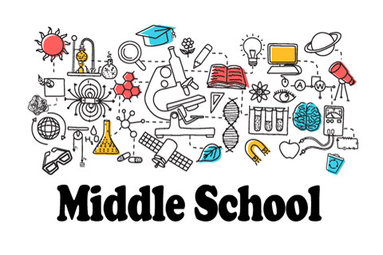

**School Community Team**

* Yes, I am interested and wish to join the School Council.
* Please contact me so I can learn more about the School Council.
* Please send me notifications about future meetings and updates.

Name:

Child’s Name and Grade:

Address:

Phone Number:

Email address:

4

**Share Your Thoughts**

We want to hear from you. If you have any suggestions or if there is any part of this policy that you feel is not satisfactory with the students’ and the school’s goals for academic achievement, please provide us with your comments in the space provided and leave this form in the Main Office:

Name: (optional)

Telephone Number: (optional)

